Creating Of REQUEST and Working with variables ,Collections.

Just On three dots of Collection Name. ADD Request.

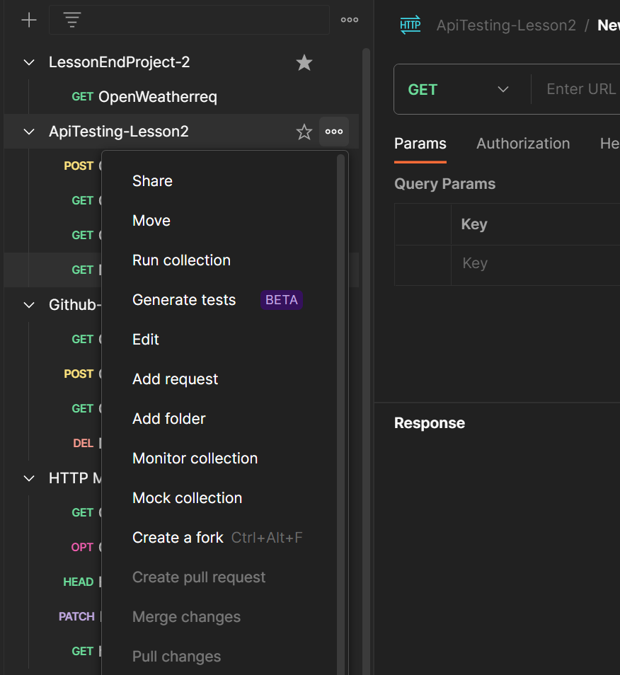

We get New Request , Name the request. And Give the values to run the Postman .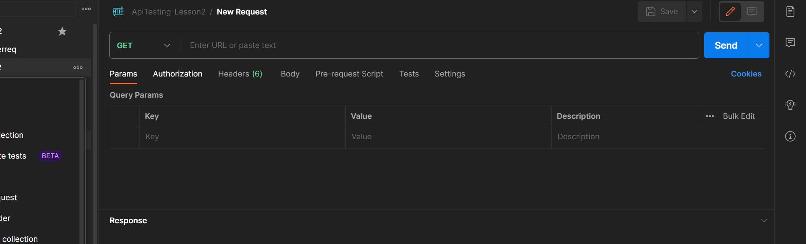

Just Click on Collections APITEsting-Lesson2 .. We find the varaibles and we pass some values to use it in Requests.

